If you are a Special Olympics athlete or the parent/guardian/caregiver of a Special Olympics Athlete, these instructions are designed to help you electronically complete the Registration and Release forms as well as the Health History portion of the medical form before you attend a MedFest or go to your own doctor for the medical exam. There are seven (7) easy steps. Please use Google Chrome to complete the form to avoid any browser complications. If you have any trouble, please contact Rachael Fuchs at rfuchs@specialolympicsnd.org.

STEP 1 | - Go to https://medform.specialolympics.org  - Select “United States.”  - Read the instructions on the next page and select “Start”  NOTE: you can’t save and return to the form so please be prepared to answer all the health history questions. If you are familiar with the medical history of the athlete, it should only take 5-10 minutes to complete. |  | 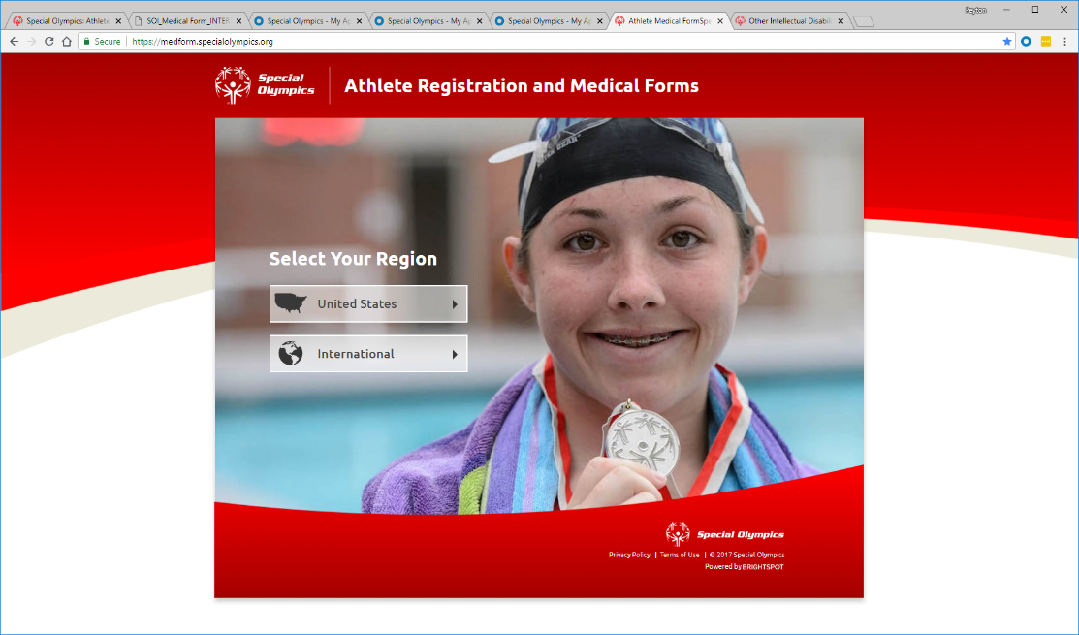
STEP 2 | - Complete the registration and medical fields, as prompted. Required fields are marked with *  - Click “Continue” to move to next page  TIP: If you do not understand a question, click the 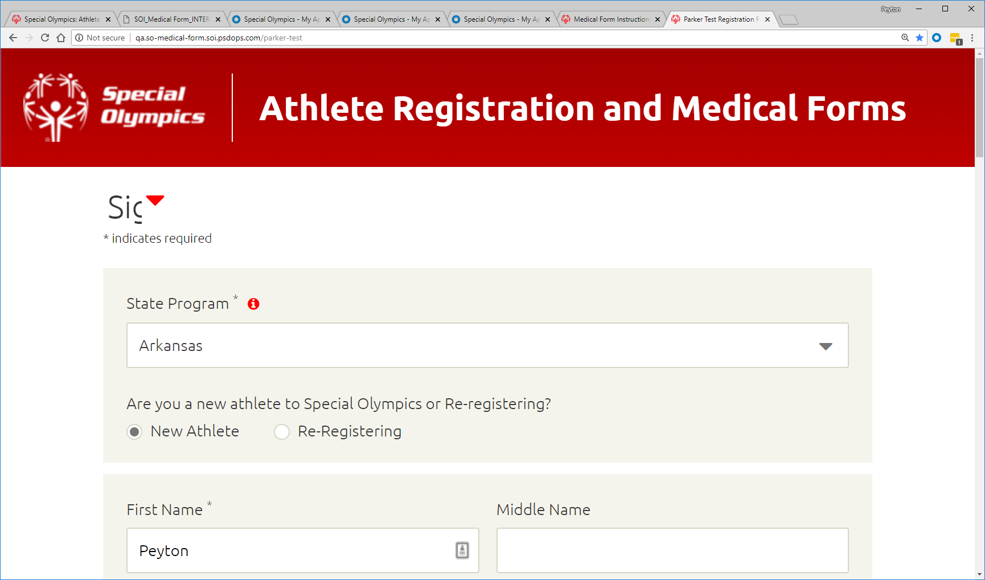button to get more information and a description  At the top of the screen you can see where you are in the process of the information to be submitted. |  | 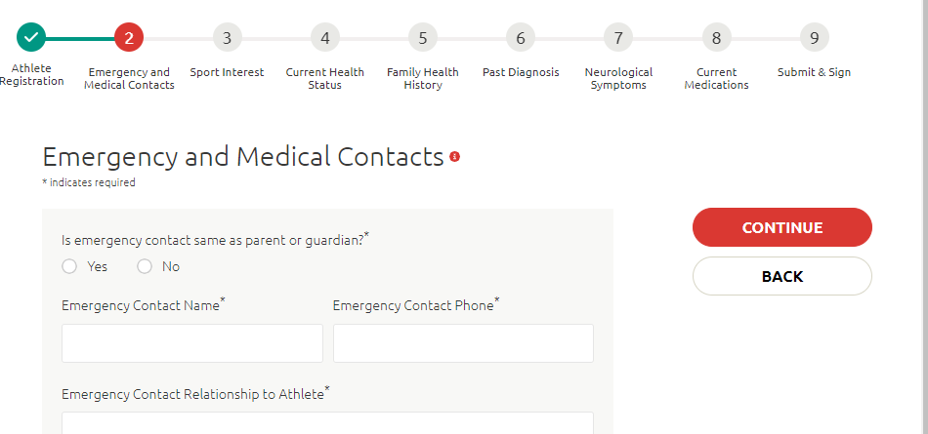
STEP 3 | - On the last page, enter contact information for the person completing the form and who will be the one signing the release forms on the next step.  - This person is the individual who will also receive a copy of the completed health history and signed release form.  - They should be legally able to sign forms on behalf of the athlete.  - Please be sure to check the acknowledgement at the bottom. |  | 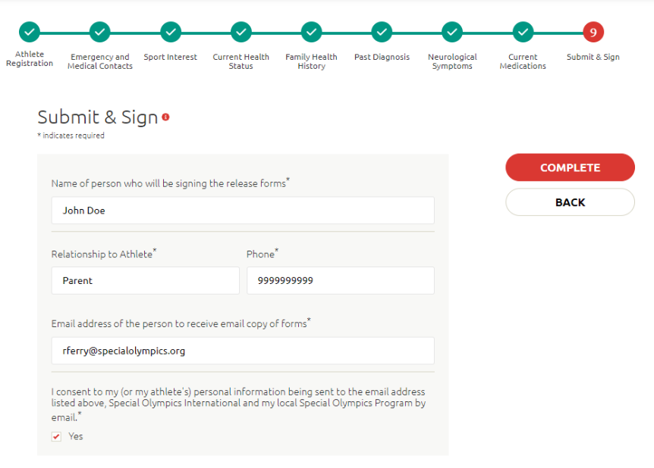
STEP 4 | You will receive an email with a link to complete the forms on Adobe Sign.  - If prompted, click the “Continue” button to agree to the Adobe Terms of Use and Privacy Policy  - If you do not want to continue with the electronic signature process you can select another option (such as download) under “Options”
STEP 5 | Review the pages and make any necessary corrections. And then sign the release forms. There are two places you will be asked to sign/initial:  - Athlete Release Form  - Athlete Likeness form (OPTIONAL)  Once all the lines are signed, click “Click to Approve”  NOTE: The Click to Approve button will not appear if a required field has not been completed.  TIP: The first time you sign you will be asked to adopt a signature.  If the wrong signature line is showing up, go to page 5 of the document and change the “Athlete Ability to Consent” to “NO” or “YES” as appropriate. This will change the signature line to the parent/guardian or athlete section accordingly. You will need to change the name. | 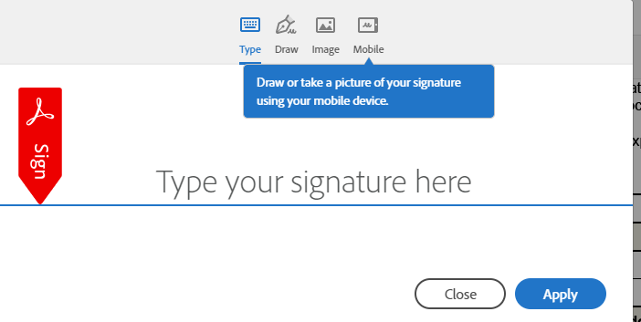  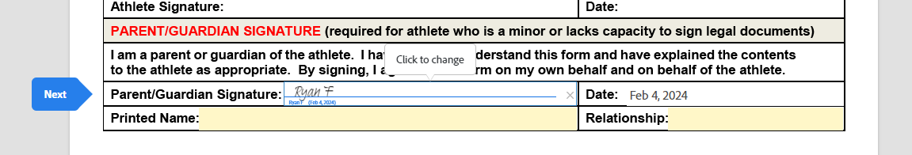
STEP 6 | From the confirmation page, you can download a copy of the forms that were just signed.  If you do not create an account, you will not be able to access this form again until the Program approves it.  You will receive a confirmation email once the Program has completed the approval process. | 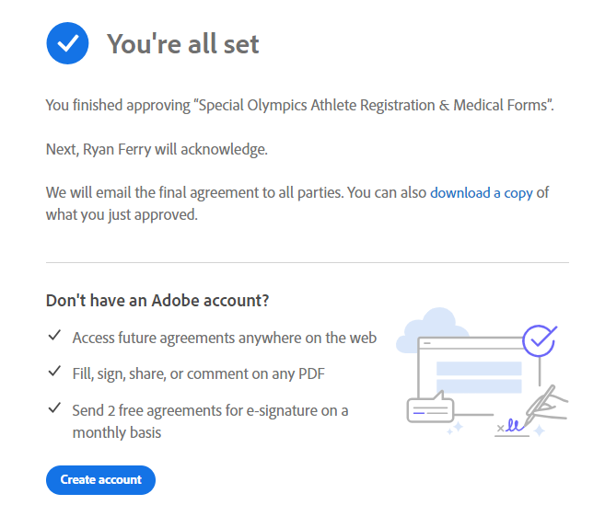
STEP 7 | If signed electronically, the health history and release forms will automatically be sent back to the Special Olympics Program. However, until the completed page 3 of the medical (the medical exam by a healthcare professional) are received by the Program, the athlete is not registered for Special Olympics.  If you are attending a MedFest event at your Special Olympics Program, the Program has received your Health History, but we still recommend that you print a copy.  Thank you for taking the time to complete the Online Registration Form!

